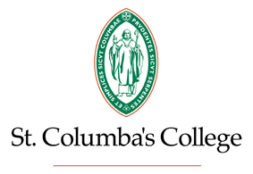

Kilmashogue Lane

Whitechurch

Dublin 16

**Co-educational Boarding and Day**

**Secondary School**

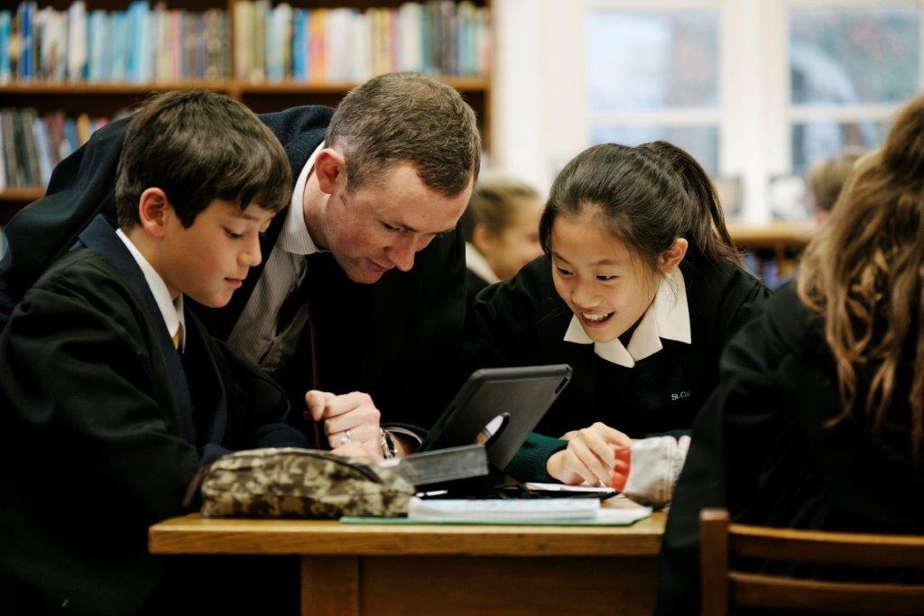

OPEN EVENING

**Thursday 16th May 2019**

**from**

**6.30pm - 8.30pm**

2018 Average LC Points: 484 per Candidate

Small classes: average of 16 - Teacher/pupil ratio of 1:7

Teachers will be available to answer your questions and pupil-led tours will be organised.

**All are welcome but are asked to contact Amanda Morris, Admissions, on [admissions@stcolumbas.ie](mailto:admissions@stcolumbas.ie) to book.**

**More details on www.stcolumbas.ie and 01 490 6791**